# Standing Waves on a String

**Pre-lab questions**

1. What is the goal of this experiment? What physics and general science concepts does this activity demonstrate to the student?
2. What is the relationship between the string length and the wavelength of a standing wave?
3. Should the wavelength of a standing wave depend on the string tension, for a given frequency?

The goal of the experiment is to understand the creation of standing waves on a string by superposition of forward- and backward-traveling waves, and to study their dependence on string tension and vibration frequency.

**Introduction**

Waves (energy) have properties that are unlike particles (matter). While two material objects cannot occupy the same space at the same time, that is not true of waves. They can, and do, travel through each other in the same space without difficulty. Where the waves overlap, their amplitudes add directly, yielding a superposed wave in that space. Standing waves are a special case of two waves overlapping each other in the same space with some additional boundary conditions.

Standing waves (stationary waves) are produced by the addition of two traveling waves, both of which have the same wavelength and speed, but travel in opposite directions through the same medium. Figure 1 shows such a system, where a mechanical vibrator produces a wave on a string which moves to the right while reflection from a fixed end produces an inverted, left traveling wave. Where the two waves are always 1800 out of phase, superposition of their amplitudes gives very little net motion (none if the amplitudes are the same). Such places are called nodes (see Figure 1).

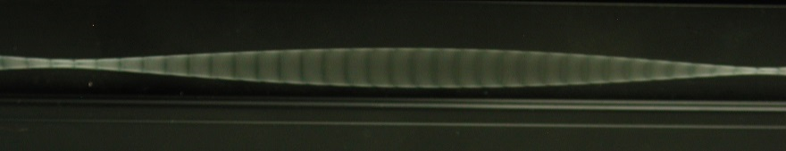

Figure 1: Standing Wave Photo

Where the two waves are in phase, the motion is maximum. These positions are call anti-nodes. Figure 2 shows a representation of a standing wave.

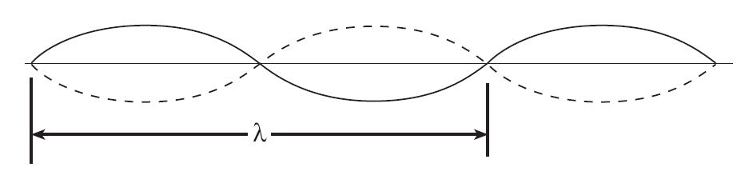

Figure 2: Standing Wave Representation

This representation shows the two extreme positions of the string.

This matches well what the eye or camera sees since the string speed is minimum at the extremes. However, don’t forget that the string goes through all of the positions in between the extremes as shown by the blur in Figure 1. Note that as shown in Figure 2, the node-to-node distance is one-half of the wavelength. The necessary conditions for the production of standing waves on a stretched string fixed at both ends is the length of the string be equal to an integer number of half wavelengths so that there can be a node at each fixed end.

**Equipment**

String vibrator, force sensor, C-clamp, patch cords, tape measure

**Experiment**

The general appearance of waves can be illustrated by investigating standing waves in a string. This type of wave is very important because most of the vibrations of extended bodies, such as the prongs of a tuning fork or the strings of a piano, are standing waves. The purpose of this experiment is to examine how the tension required to produce a standing wave in a vibrating string of fixed length and mass density is affected by the wavelength and the frequency of the wave.

For this experiment, where the standing wave condition is set by having both ends stationary, one fixed end is where the string attaches to the force sensor and the other is where the string attaches to the mechanical vibrator. The end attached to the force sensor is a true node, but the end attached to the metal wand on the vibrator is not exactly a node since the wand vibrates up a down a little. Close examination (see Figure 3) shows that the true node would be a little to the left of the knot so the effective string length will be a bit longer than we measure. However, the difference does not appear to be more than a few millimeters, so is only a fraction of a percent.

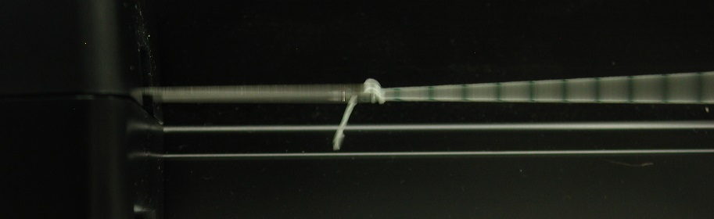

Figure 3: Vibrator ~ Node

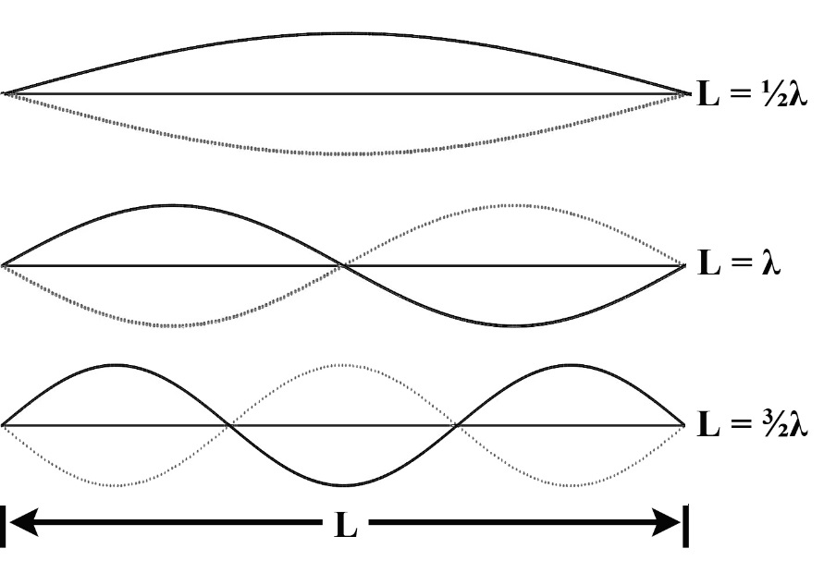

Figure 4: Modes of Vibration

Theory: Standing Waves in Strings

A stretched string has many natural modes of vibration (three examples are shown in Figure 4 above). If the string is fixed at both ends then there must be a corresponding node at each end where the string is stationary. It may vibrate as a single segment, in which case the length (*L*) of the string is equal to 1/2 the wavelength (*λ*) of the wave. It may also vibrate in two segments with a node at each end and one node in the middle; then the wavelength is equal to the length of the string. It may also vibrate with a larger integer number of segments. In every case, the length of the string equals some integer number of half wavelengths. If you drive a stretched string at an arbitrary frequency, you will probably not see any particular mode; many modes will be mixed together. But, if the tension and the string's length are correctly adjusted to the frequency of the driving vibrator, one vibrational mode will occur at a much greater amplitude than the other modes.

For any wave with wavelength *λ* and frequency *f*, the speed of wave propagation, *v*, is

*v* = *λf* (1)

(This is a consequence of constant speed motion.) The speed, *v*, of a wave on a string is also related to the tension in the string, *F*, and the linear density (mass/length), *μ*, by

*v*2 = *F*/*μ* = *λ*2*f*2 (2)

Let *L* be the length of the string and *n* the number of segments in the standing wave. (Note that *n* is *not* the number of nodes). Since a segment is 1/2 wavelength then

*λ* = 2*L*/*n* where *n* = 1, 2, 3, … (3)

Solving Equation 2 for the tension yields:

*F* = *μλ*2*f*2 (4)

In the first part of the experiment, we will hold *λ* constant by always choosing a two segment pattern so that *λ* = *L* (since *n* = 2) and vary the frequency while measuring the tension at which a two segment standing wave appears. By plotting *F* versus *f*2, we should see a straight line with a slope of *μλ*2.

In the second part, we hold the frequency constant and vary the tension (Figure 4) to get standing waves with different numbers of segments, so different values of *λ*. Plotting *F* versus *λ*2 should give a straight line with slope *μf*2.

Determining String Mass Density

Your lab group will have a piece of string about one meter long. However, the mass of 1 m of string is about ¼ g which is too small for most scales to measure with much precision. Fortunately, the string is very uniform (varies by less than 1%) and not very stretchy, so we can measure the mass of a common, long piece to determine the average mass density to greater accuracy.

1. Use the tape measure to determine the length of the long string supplied to a precision of ± 1 cm.
2. Use the best available scale to determine the mass of the string. To optimize precision, either zero the scale carefully or note where the equilibrium position is with nothing in the pan and use that position to achieve balance. Record the mass and calculate the mass/length.

Setup

1. Setup as shown in Figure 5. Clamp the String Vibrator firmly to the table. Attach two banana cables from Output 1 on the 850 Universal Interface to the Inputs on the String Vibrator. Polarity does not matter.
2. Attach the Force Sensor to any of the *PASPORT* inputs on the 850 Universal Interface.
3. Tie the 1 m string to the hook on the Force Sensor and to the vibrating blade on the String Vibrator. The oscillation of the string is all in a vertical plane.
4. In PASCO Capstone, create a Digits Display and select the Force. Then turn on the Statistics with the Mean selected.

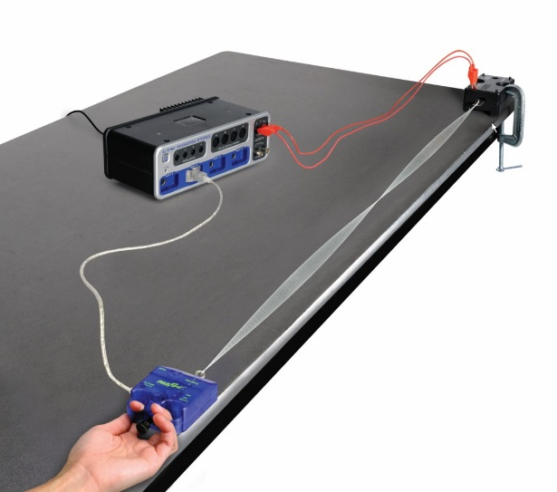

Figure 5: Standard Setup

|  |  |
| --- | --- |
| Frequency  (Hz) | Tension  (N) |
| 60 |  |
| 85 |  |
| 104 |  |
| 120 |  |
| 134 |  |
| 147 |  |

1. Create a table as shown. Create User-Entered Data sets called “Frequency” with units of Hz and “Tension” with units of N.
2. Set the sample rate to 20 Hz.

Constant Wavelength Procedure

1. Move the Force Sensor so the string is under tension and determine the length of the string between the knot attached to the blade on the String Vibrator and the knot attached to the hook on the Force Sensor. We will adjust for two segments (as in Figure 5) for each case, so the knot to knot distance will be the wavelength. Record your value.
2. Click on the Signal Generator at the left of the screen. Open Output 1 and set for a Sine Waveform at an Amplitude of 5 V and a frequency of 60 Hz. You may vary the Amplitude during the experiment. Increasing the Amplitude will increase the size of the standing wave. **Do not** exceed 10 V! If the String Vibrator begins to clatter, it is being overdriven and you should decrease the Amplitude.
3. Click On to turn the String Vibrator on.
4. Adjust the tension in the string to get the string vibrating in two segments (as in Figure 5) and to maximize the amplitude of the standing wave. It is easiest to start with the tension too high and slowly decrease it.
5. When you have the maximum standing wave, click RECORD and collect data for about 10 seconds. Click STOP.
6. The force shown in the Force digits display is the average value over the 10 seconds. Ignore the minus sign. Record this value in the “Tension” column of the table in the 60 Hz row.
7. Repeat for frequencies of 85 Hz, 104 Hz, 120 Hz, 134 Hz, and 147 Hz.
8. Question: Why do we have this rather strange looking choice of frequencies? Hint: See the graph in the Analysis section.

Constant Wavelength Analysis

1. Create a graph of Tension vs. frequency. Use the QuickCalcs on the frequency axis to linearize the data.
2. Based on Equation 4, what should be the slope and y-axis intercept of a Tension vs. frequency2 plot? Include an estimate of the uncertainty in the slope. The uncertainty here is due to the uncertainty in the mass density, so the percent uncertainty in the calculated slope is the same as the % uncertainty in the mass density from the String Mass Density.
3. Click on the Scale-to-Fit icon from the graph toolbar.
4. Select a Linear fit.
5. How well do the experimental slope and intercept from step 4 agree with the value you calculated for slope and intercept in step 2? Discuss briefly. What does this show?

Constant Frequency Procedure

|  |  |  |  |
| --- | --- | --- | --- |
| # of Segments | String Length  (m) | Wavelength  (m) | Tension Force  (N) |
| 1 |  |  |  |
| 2 |  |  |  |
| 3 |  |  |  |
| 4 |  |  |  |
| 5 |  |  |  |

1. Create a table as shown. Create User-Entered Data sets called “# of Segments”, “String Length” with units of m, and “Tension Force” with units of N. Then open the Capstone calculator and make the calculation with units of m: Wavelength ‎= 2*[String Length (m)]/[# of segments‎]
2. Move the Force Sensor so the string is under tension and determine the length of the string between the knot attached to the blade on the String Vibrator and the knot attached to the hook on the Force Sensor. Enter this length in the “String Length” column of the table in each of the five rows (same value in each row).
3. Click on the Signal Generator at the left of the screen. Open Output 1 and set for a Sine Waveform at an Amplitude of 5 V and a frequency of 150 Hz. You may vary the Amplitude during the experiment. Increasing the Amplitude will increase the size of the standing wave. **Do not** exceed 10 V! If the String Vibrator begins to clatter, it is being overdriven and you should decrease the Amplitude.
4. Click On to turn the String Vibrator on.
5. Adjust the tension in the string to get the string vibrating in one segment (nodes only at the ends) and to maximize the amplitude of the standing wave. It is easiest to start with the tension too high and slowly decrease it.
6. When you have the maximum standing wave, click RECORD and collect data for about 10 seconds. Click STOP.
7. The force shown in the Tension Force box is the average value over the 10 seconds. Ignore the minus sign. Record this value in the “Tension Force” column of the table in the first row.
8. Repeat for standing wave patterns with 2, 3, 4, and 5 segments.

Constant Frequency Analysis

1. Create a graph of Tension Force vs. Wavelength. Use the QuickCalcs on the wavelength axis to linearize the data.
2. Based on Equation 4 from Standing Wave Theory, what should be the slope and y-axis intercept of the Tension vs. wavelength2 plot? Include an estimate of the uncertainty in the slope. The uncertainty here is due to the uncertainty in the mass density, so the % uncertainly in the calculated slope is the same as the % uncertainty in the mass density from the String Mass Density table under the String Mass tab.
3. Click on the Scale-to-Fit icon from the graph toolbar and select a Linear Fit.
4. How well do the experimental slope and intercept from step 3 agree with the value you calculated for slope and intercept in step 2? Discuss briefly. What does this show?